VISVESVARAYA TECHNOLOGICAL UNIVERSITY
“JnanaSangama”, Belgaum -590014, Karnataka.


LAB REPORT on

Big Data Analytics

Submitted by

TARUN GOWDA V (1WA23CS014)

in partial fulfillment for the award of the degree of
BACHELOR OF ENGINEERING
in

COMPUTER SCIENCE AND ENGINEERING


B.M.S. COLLEGE OF ENGINEERING
(Autonomous Institution under VTU)
BENGALURU-560019
Jan-2026 to May-2026

B. M. S. College of Engineering,
Bull Temple Road, Bangalore 560019
(Affiliated To Visvesvaraya Technological University, Belgaum)
Department of Computer Science and Engineering


CERTIFICATE

This is to certify that the Lab work entitled “Big Data Analytics” carried out by Tarun Gowda V (1WA23CS014), who is a bona fide student of B. M. S. College of Engineering. It is in partial fulfillment for the award of Bachelor of Engineering in Computer Science and Engineering of the Visvesvaraya Technological University, Belgaum during the year 2026. The Lab report has been approved as it satisfies the academic requirements in respect of a Big Data Analytics - (23CS6PCBDA) work prescribed for the said degree.

Dr.Anita H K Dr. Kavitha Sooda
Assistant Professor Professor and Head
Department of CSE Department of CSE
BMSCE, Bengaluru BMSCE, Bengaluru

INDEX SHEET

Sl. No. | Experiment Title | Page No.
1. | MongoDB CRUD Operations | 1-5
2. | Cassandra Employee | 6-7
3. | Cassandra Library | 8-9
4. | Hadoop Commands | 10-11
5. | Hadoop Word Count | 12-14
6. | Hadoop Weather program | 15-20
7. | Hadoop Top N Program | 21-24
8. | Scala Program | 25
9. | Spark program | 26
10. | Open Ended question | 27

Github Link: https://github.com/TarunGV/BDA-LAB

Course Outcome

CO1 | Apply the concepts of NoSQL, Hadoop, Spark for a given task
CO2 | Analyze data analytic techniques for a given problem
CO3 | Conduct experiments using data analytics mechanisms for a given problem

LAB 1

MongoDB- CRUD Demonstration

Student database
- Create a database “Student” with the following attributes Rollno, Age, ContactNo, Email-Id.

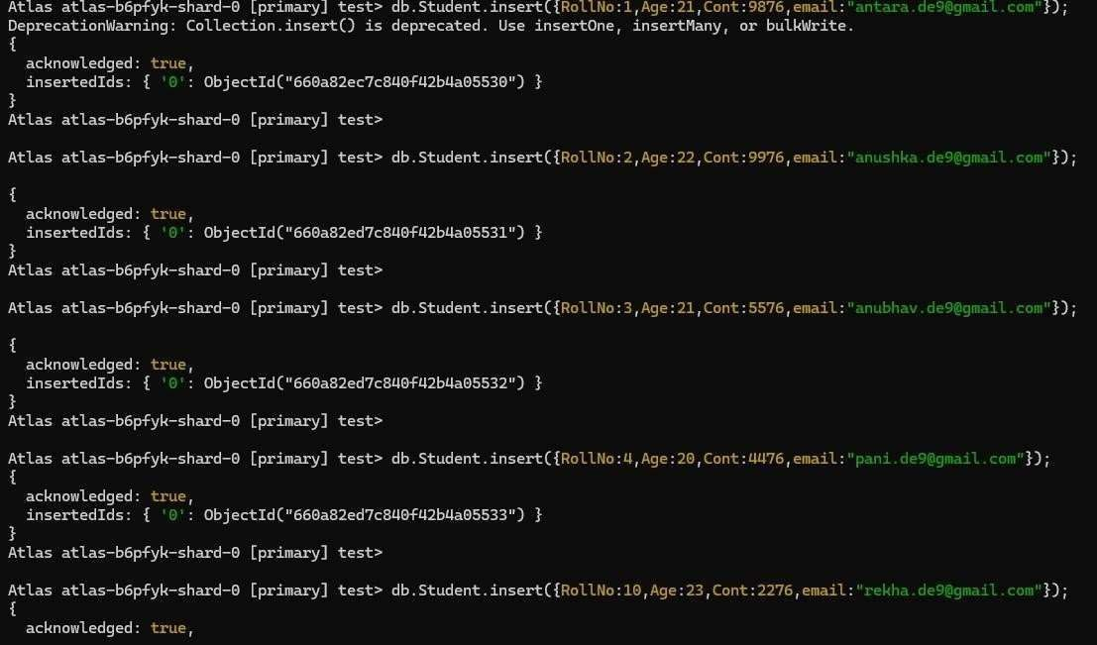
- Insert appropriate values (at least 5)

- View the data

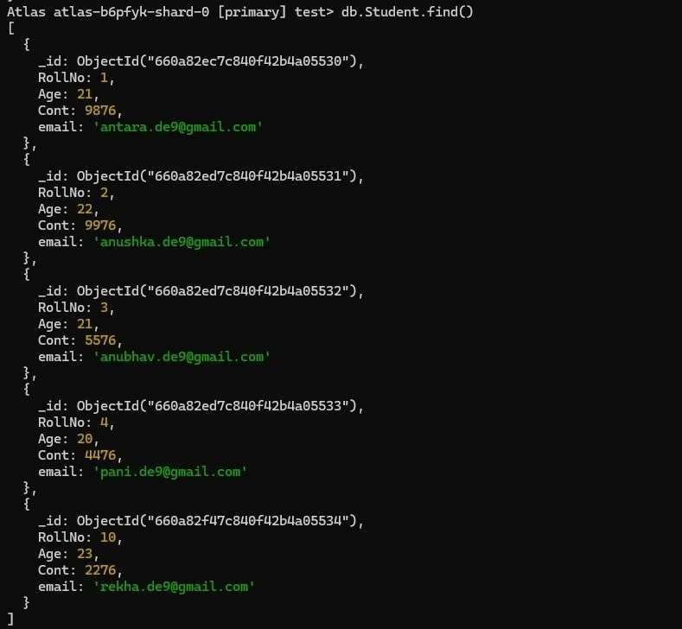

- Write a query to update the Email-Id of a student with rollno 10.

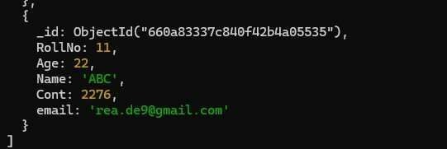

- Replace the student name from “ABC” to “FEM” of rollno 11.
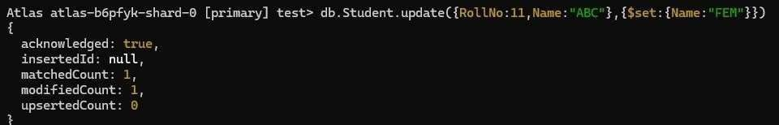

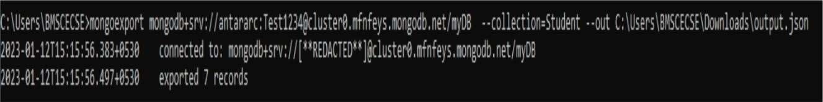
- Export the created table into local file system
- Drop the table

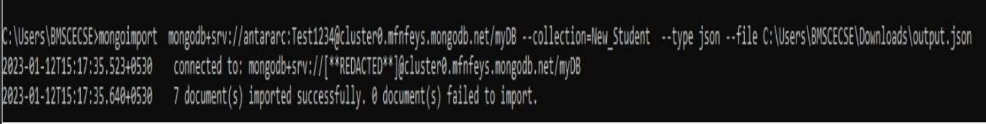
- Import a given csv dataset from local file system into mongodb collection.

Customer database
- Create a collection by name Customers with the following attributes. Cust_id, Acc_Bal, Acc_Type

- Insert at least 5 values into the table

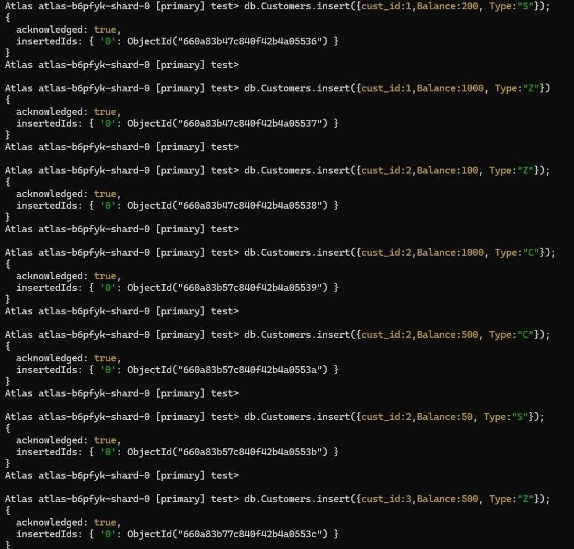
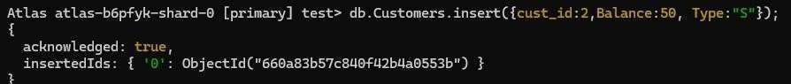

- Write a query to display those records whose total account balance is greater than 1200 of account type ‘Z’ for each customer_id.
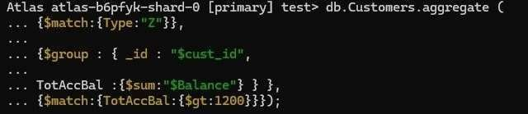

- Determine Minimum and Maximum account balance for each customer_id.
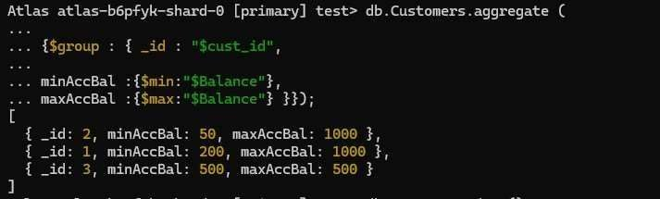

- Drop the table

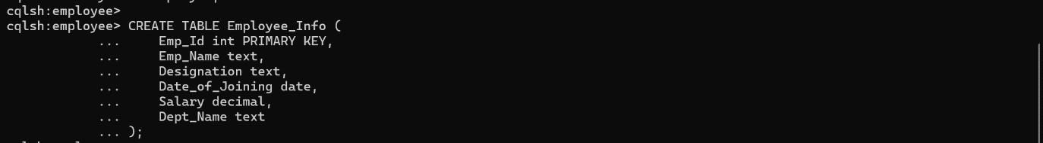
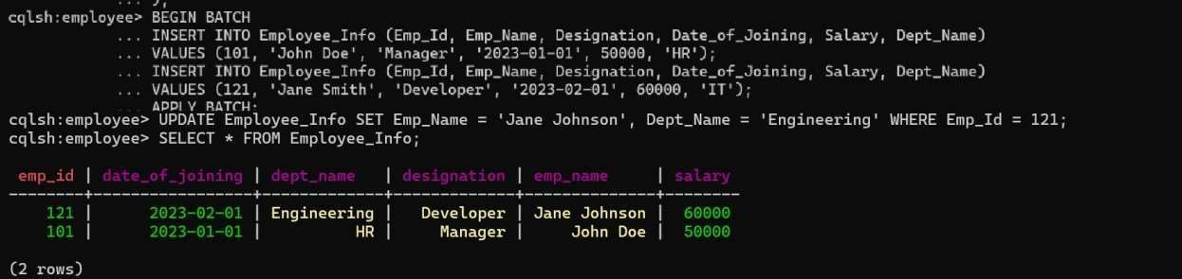
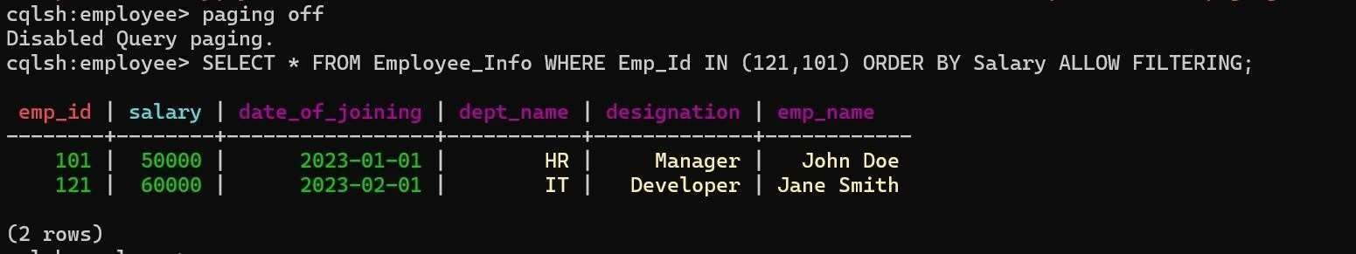
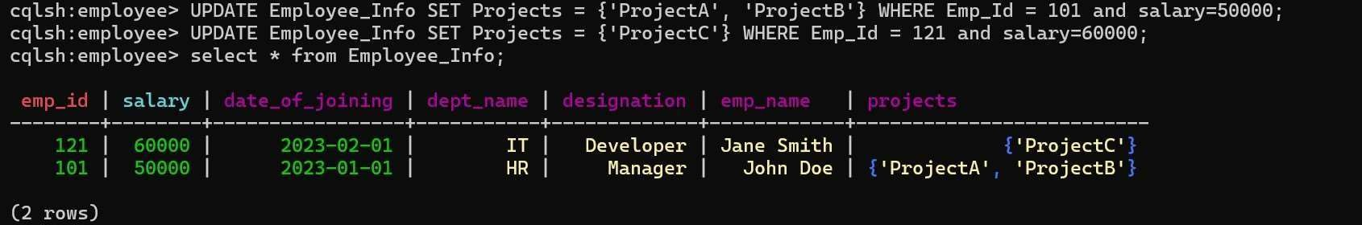

LAB 2

Perform the following DB operations using Cassandra

Employee Database

- Create a keyspace by name Employee

- Create a column family by name Employee-Info with attributes Emp_Id Primary Key,

Emp_Name, Designation, Date_of_Joining, Salary, Dept_Name

- Insert the values into the table in batch

- Update Employee name and Department of Emp-Id 121

- Sort the details of Employee records based on salary

- Alter the schema of the table Employee_Info to add a column Projects which stores a set of Projects done by the corresponding Employee.
- Update the altered table to add project names.


- Create a TTL of 15 seconds to display the values of Employees.
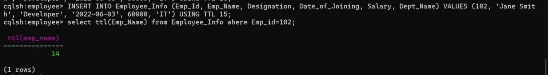

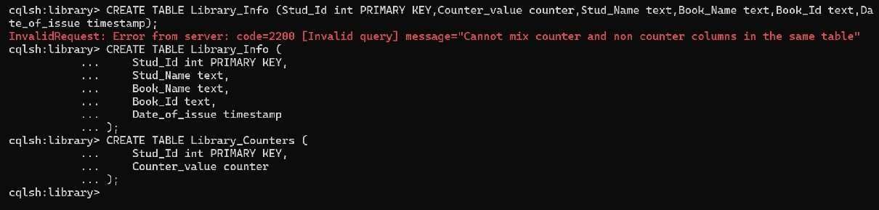
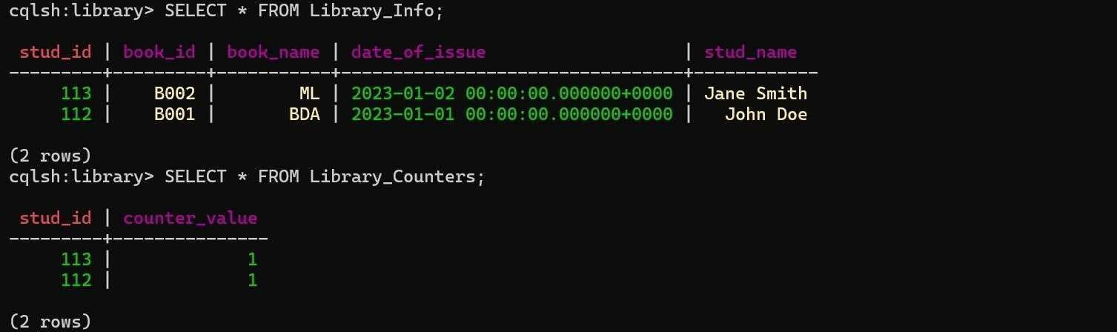
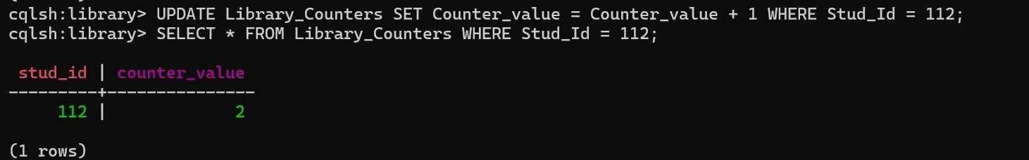

LAB 3

Perform the following DB operations using Cassandra
- Create a keyspace by name Library

- Create a column family by name Library-Info with attributes Stud_Id Primary Key, Counter_value of type Counter, Stud_Name, Book-Name, Book-Id, Date_of_issue

- Insert the values into the table in batch

- Display the details of the table created and increase the value of the counter

- Write a query to show that a student with id 112 has taken a book “BDA” 2 times.

- Export the created column to a csv file
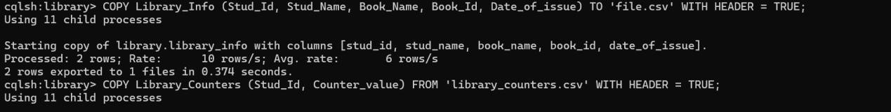

- Import a given csv dataset from local file system into Cassandra column family
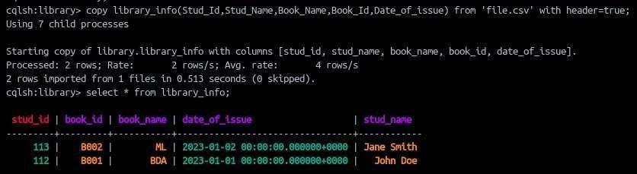

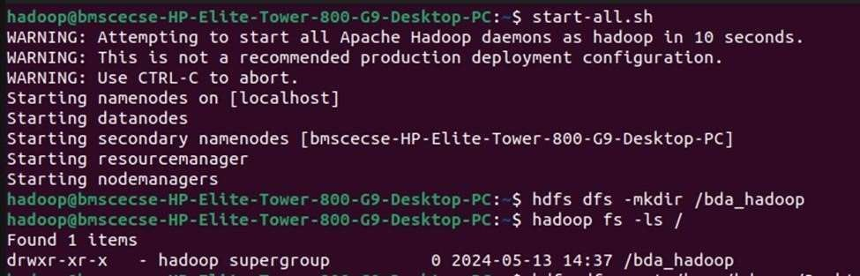
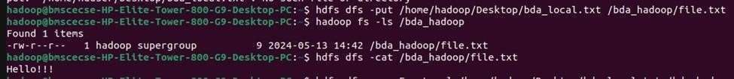
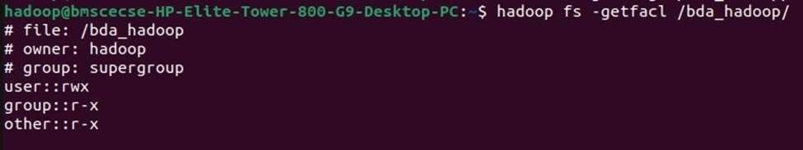

LAB 4

Execution of HDFS Commands for interaction with Hadoop Environment. (Minimum 10 commands to be executed)
- mkdir
- ls

- put

- copyFromLocal

- get

- copyToLocal

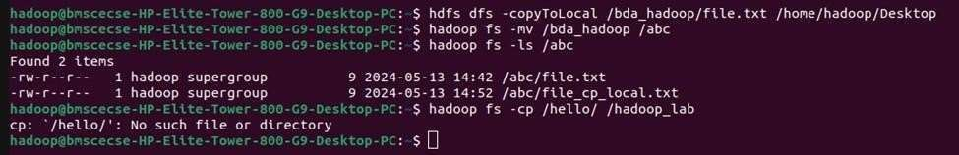
- cat

- mv

- cp

LAB 5

Implement WordCount Program on Hadoop framework

Word Count Program:
Mapper code: You have to copy paste this program into the WCMapper Java Class file import java.io.IOException; import org.apache.hadoop.io.IntWritable; import org.apache.hadoop.io.LongWritable; import org.apache.hadoop.io.Text; import org.apache.hadoop.mapred.MapReduceBase; import
org.apache.hadoop.mapred.Mapper; import
org.apache.hadoop.mapred.OutputCollector; import org.apache.hadoop.mapred.Reporter;
public class WCMapper extends MapReduceBase implements Mapper<LongWritable, Text, Text, IntWritable> { public void map(LongWritable key, Text value, OutputCollector<Text,
IntWritable> output,
Reporter rep) throws IOException { String line = value.toString(); for (String word : line.split(" ")) { if (word.length() > 0) { output.collect(new Text(word), new IntWritable(1)); }
}
}
}

Reducer Code: You have to copy paste this program into the WCReducer Java Class file import java.io.IOException; import java.util.Iterator; import org.apache.hadoop.io.IntWritable; import org.apache.hadoop.io.Text; import org.apache.hadoop.mapred.MapReduceBase; import
org.apache.hadoop.mapred.OutputCollector; import org.apache.hadoop.mapred.Reducer; import org.apache.hadoop.mapred.Reporter;
public class WCReducer extends MapReduceBase implements Reducer<Text, IntWritable, Text, IntWritable> { public void reduce(Text key, Iterator<IntWritable> value, OutputCollector<Text,
IntWritable>
output, Reporter rep) throws IOException { int count = 0;
while (value.hasNext()) { IntWritable i = value.next(); count += i.get();
} output.collect(key, new IntWritable(count)); }
}

Driver Code: You have to copy paste this program into the WCDriver Java Class file. import java.io.IOException; import org.apache.hadoop.conf.Configured; import org.apache.hadoop.fs.Path; import org.apache.hadoop.io.IntWritable; import org.apache.hadoop.io.Text; import org.apache.hadoop.mapred.FileInputFormat;

import org.apache.hadoop.mapred.FileOutputFormat; import org.apache.hadoop.mapred.JobClient; import org.apache.hadoop.mapred.JobConf; import org.apache.hadoop.util.Tool; import org.apache.hadoop.util.ToolRunner; public class WCDriver extends Configured implements Tool { public int run(String[] args) throws IOException { if (args.length < 2) {
System.out.println("Please give valid inputs"); return
-1;
}
JobConf conf = new JobConf(WCDriver.class); conf.setJobName("Word Count");
FileInputFormat.setInputPaths(conf, new Path(args[0])); FileOutputFormat.setOutputPath(conf, new Path(args[1])); conf.setMapperClass(WCMapper.class); conf.setReducerClass(WCReducer.class); conf.setMapOutputKeyClass(Text.class); conf.setMapOutputValueClass(IntWritable.class); conf.setOutputKeyClass(Text.class); conf.setOutputValueClass(IntWritable.class); JobClient.runJob(conf); return 0;
} public static void main(String[] args) throws Exception
{
int exitCode = ToolRunner.run(new WCDriver(), args); System.out.println(exitCode);
}
}

OUTPUT
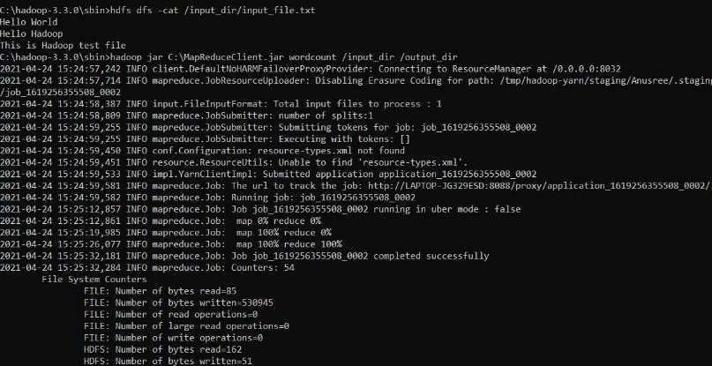

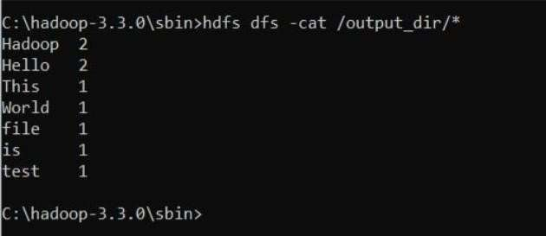

LAB 6
From the following link extract the weather data https://github.com/tomwhite/hadoop-Book/tree/master/input/ncdc/all
Create a Map Reduce program to
- find average temperature for each year from the NCDC data set.

AverageDriver package temp; import org.apache.hadoop.fs.Path; import org.apache.hadoop.io.IntWritable; import org.apache.hadoop.io.Text; import
org.apache.hadoop.mapreduce.Job; import org.apache.hadoop.mapreduce.lib.input.FileInputFormat; import org.apache.hadoop.mapreduce.lib.output.FileOutputFormat; public class AverageDriver { public static void main(String[] args) throws Exception { if (args.length != 2) {
System.err.println("Please Enter the input and output parameters"); System.exit(-1);
}
Job job = Job.getInstance(); job.setJarByClass(AverageDriver.class); job.setJobName("Max temperature"); FileInputFormat.addInputPath(job, new Path(args[0])); FileOutputFormat.setOutputPath(job, new Path(args[1])); job.setMapperClass(AverageMapper.class); job.setReducerClass(AverageReducer.class); job.setOutputKeyClass(Text.class); job.setOutputValueClass(IntWritable.class); System.exit(job.waitForCompletion(true) ? 0 : 1); }
}

AverageMapper package temp; import java.io.IOException; import org.apache.hadoop.io.IntWritable; import org.apache.hadoop.io.LongWritable; import org.apache.hadoop.io.Text; import org.apache.hadoop.mapreduce.Mapper; public class AverageMapper extends Mapper<LongWritable, Text, Text, IntWritable> { public static final int MISSING = 9999; public void map(LongWritable key, Text value, Context context) throws IOException,
InterruptedException { int temperature;
String line = value.toString(); if (line.length() < 93) { return;
}

String year = line.substring(15, 19); if (line.charAt(87)
== '+') { temperature = Integer.parseInt(line.substring(88, 92));
} else { temperature = Integer.parseInt(line.substring(87, 92));
}
String quality = line.substring(92, 93); if (temperature != MISSING && quality.matches("[01459]")) { context.write(new Text(year), new IntWritable(temperature));
}
}
}

AverageReducer package temp; import java.io.IOException; import org.apache.hadoop.io.IntWritable; import org.apache.hadoop.io.Text; import org.apache.hadoop.mapreduce.Reducer; public class AverageReducer extends Reducer<Text, IntWritable, Text, IntWritable> { public void reduce(Text key, Iterable<IntWritable> values,
Context context) throws IOException, InterruptedException { int sum = 0; int count = 0; for
(IntWritable value : values) { sum += value.get(); count++;
} if (count > 0) { int average = sum / count; context.write(key, new IntWritable(average)); }
}
}
OUTPUT

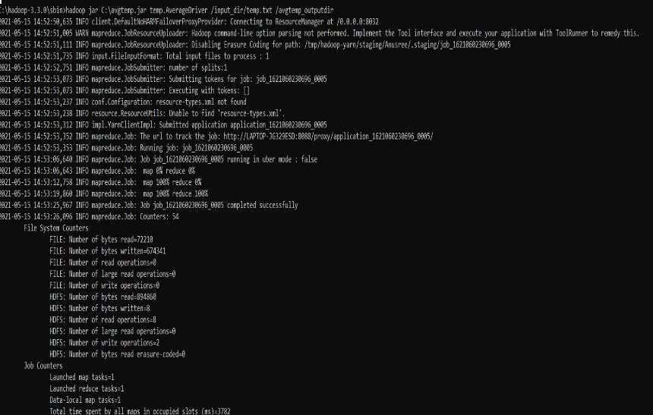

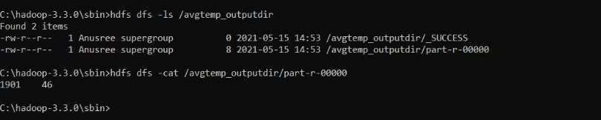

find the mean max temperature for every month

MeanMaxDriver.class package meanmax; import org.apache.hadoop.fs.Path; import org.apache.hadoop.io.IntWritable; import org.apache.hadoop.io.Text; import org.apache.hadoop.mapreduce.Job;
import org.apache.hadoop.mapreduce.lib.input.FileInputFormat; import org.apache.hadoop.mapreduce.lib.output.FileOutputFormat; public class MeanMaxDriver {
public static void main(String[] args) throws Exception { if (args.length != 2) {

System.err.println("Please enter the input and output parameters"); System.exit(-1);
}
Job job = Job.getInstance(); job.setJarByClass(MeanMaxDriver.class); job.setJobName("Mean and Max Temperature"); FileInputFormat.addInputPath(job, new Path(args[0])); FileOutputFormat.setOutputPath(job, new Path(args[1])); job.setMapperClass(MeanMaxMapper.class); job.setReducerClass(MeanMaxReducer.class); job.setOutputKeyClass(Text.class); job.setOutputValueClass(IntWritable.class); System.exit(job.waitForCompletion(true) ? 0 : 1); }
}

MeanMaxMapper.class package meanmax; import java.io.IOException; import org.apache.hadoop.io.IntWritable; import org.apache.hadoop.io.LongWritable; import org.apache.hadoop.io.Text; import org.apache.hadoop.mapreduce.Mapper; public class MeanMaxMapper extends Mapper<LongWritable, Text, Text, IntWritable> { public static final int MISSING = 9999; public void map(LongWritable key, Text value, Context context) throws IOException, InterruptedException {
int temperature;
String line = value.toString(); if (line.length() < 93) return;
String month = line.substring(19, 21); if (line.charAt(87) == '+') { temperature = Integer.parseInt(line.substring(88, 92));
} else { temperature = Integer.parseInt(line.substring(87, 92));
}
String quality = line.substring(92, 93); if (temperature != MISSING && quality.matches("[01459]")) { context.write(new Text(month), new IntWritable(temperature));
}
}
}
MeanMaxReducer.class package meanmax; import java.io.IOException; import org.apache.hadoop.io.IntWritable; import org.apache.hadoop.io.Text; import org.apache.hadoop.mapreduce.Reducer; public class MeanMaxReducer extends Reducer<Text, IntWritable, Text, IntWritable> {
public void reduce(Text key, Iterable<IntWritable> values, Context context) throws IOException, InterruptedException {
int maxTemp = 0; int totalTemp
= 0; int count = 0; int days = 0;

for (IntWritable value : values) { int temp = value.get(); if (temp > maxTemp) {
maxTemp = temp;
} count++; if (count == 3)
{ totalTemp += maxTemp; maxTemp = 0; count = 0; days++;
} } if (days
> 0) {
context.write(key, new IntWritable(totalTemp / days));
} else { context.write(key, new IntWritable(0)); }
}
}
OUTPUT
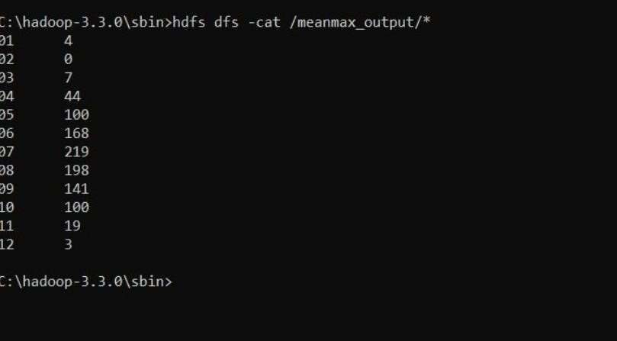

LAB 7

For a given Text file, Create a Map Reduce program to sort the content in an alphabetic order listing only top 10 maximum occurrences of words

TopNDriver.class import java.io.IOException; import java.util.StringTokenizer; import
org.apache.hadoop.conf.Configuration; import
org.apache.hadoop.fs.Path; import
org.apache.hadoop.io.IntWritable; import
org.apache.hadoop.io.Text; import
org.apache.hadoop.mapreduce.Job; import
org.apache.hadoop.mapreduce.Mapper; import
org.apache.hadoop.mapreduce.Reducer; import org.apache.hadoop.mapreduce.lib.input.FileInputFormat; import org.apache.hadoop.mapreduce.lib.output.FileOutputFormat; import org.apache.hadoop.util.GenericOptionsParser; public class TopN { public static void main(String[] args) throws Exception {
Configuration conf = new Configuration();
String[] otherArgs = (new GenericOptionsParser(conf, args)).getRemainingArgs(); if (otherArgs.length != 2) {
System.err.println("Usage: TopN <in> <out>"); System.exit(2);
}
Job job = Job.getInstance(conf); job.setJobName("Top N"); job.setJarByClass(TopN.class); job.setMapperClass(TopNMapper.class); job.setReducerClass(TopNReducer.class); job.setOutputKeyClass(Text.class); job.setOutputValueClass(IntWritable.class);
FileInputFormat.addInputPath(job, new Path(otherArgs[0])); FileOutputFormat.setOutputPath(job, new Path(otherArgs[1])); System.exit(job.waitForCompletion(true) ? 0 : 1); }
}

TopNCombiner.class package
samples.topn; import
java.io.IOException; import org.apache.hadoop.io.IntWritable;
import org.apache.hadoop.io.Text; import org.apache.hadoop.mapreduce.Reducer;

public class TopNCombiner extends Reducer<Text, IntWritable, Text, IntWritable> { public void reduce(Text key, Iterable<IntWritable> values, Context context) throws IOException, InterruptedException {
int sum = 0; for (IntWritable val : values) sum += val.get();
context.write(key, new IntWritable(sum)); }
}

TopNReducer.class package samples.topn; import java.io.IOException; import java.util.HashMap; import java.util.Map; import java.util.LinkedHashMap; import java.util.stream.Collectors; import org.apache.hadoop.io.IntWritable; import org.apache.hadoop.io.Text; import org.apache.hadoop.mapreduce.Reducer; public class TopNReducer extends Reducer<Text, IntWritable, Text, IntWritable> { private Map<Text, Integer> countMap = new HashMap<>(); public void reduce(Text key, Iterable<IntWritable> values, Context context) throws
IOException, InterruptedException { int sum = 0; for (IntWritable val
: values) { sum += val.get();
} countMap.put(new Text(key), sum);
}
protected void cleanup(Context context) throws IOException, InterruptedException { Map<Text, Integer> sortedMap = countMap.entrySet().stream().sorted(Map.Entry.<Text,
Integer>comparingByValue().reversed()).limit(20).collect(Collectors.toMap( Map.Entry::getKey,
Map.Entry::getValue, (e1, e2) -> e1,
LinkedHashMap::new)); for (Map.Entry<Text, Integer> entry
: sortedMap.entrySet()) { context.write(entry.getKey(), new IntWritable(entry.getValue()));
}
}
}

TopNMapper.class package samples.topn; import java.io.IOException; import java.util.StringTokenizer; import org.apache.hadoop.io.IntWritable; import org.apache.hadoop.io.Text; import org.apache.hadoop.mapreduce.Mapper; public class TopNMapper extends Mapper<Object, Text, Text, IntWritable> { private static final IntWritable one

= new IntWritable(1); private Text word = new Text(); private String tokens = "[_|$#<>\\^=\\[\\]\\*/\\\\,;,.\\-:()?!\"']";
public void map(Object key, Text value, Mapper<Object, Text, Text, IntWritable>.Context context) throws IOException, InterruptedException
{
String cleanLine = value.toString().toLowerCase().replaceAll(this.tokens, " "); StringTokenizer itr = new StringTokenizer(cleanLine); while (itr.hasMoreTokens()) { this.word.set(itr.nextToken().trim()); context.write(this.word, one);
}
}
}
OUTPUT
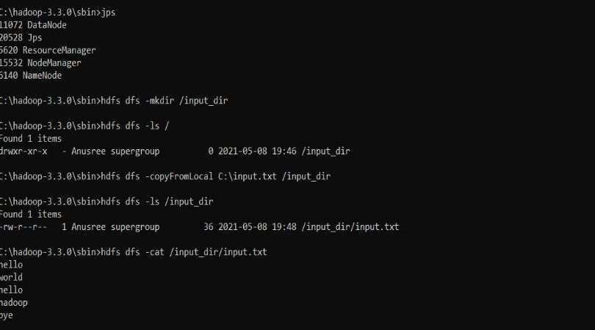

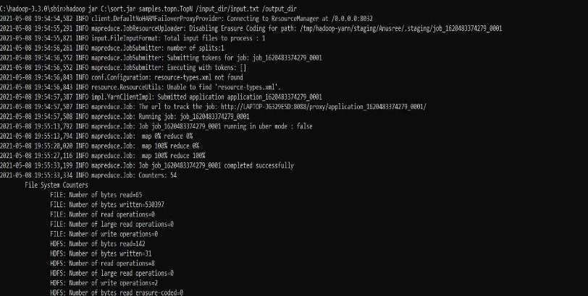
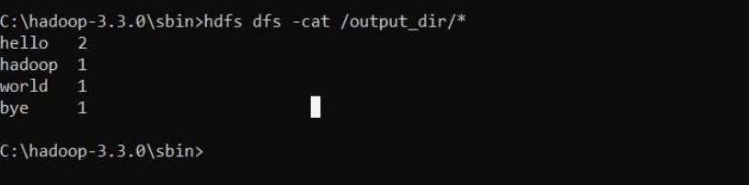

LAB 8&9

Write a Scala program to print numbers from 1 to 100 using for loop.

object ExampleForLoop1 { def main(args: Array[String]) { for(counter <- 1 to 100) { print(counter + " ")
}
println()
}
}

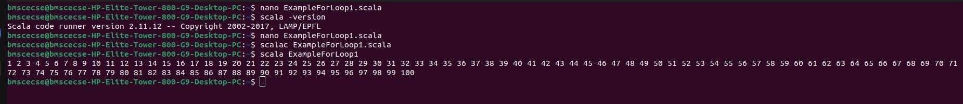
OUTPUT

Using RDD and FlatMap count how many times each word appears in a file and write out a list of words whose count is strictly greater than 4 using Spark.

from pyspark import SparkContext sc = SparkContext("local", "SimpleWordCount")

# Read file rdd = sc.textFile("file.txt") # Replace with your filename

# Count words counts = (rdd.flatMap(lambda line: line.split())
.map(lambda word: (word, 1))
.reduceByKey(lambda a, b: a + b)
.filter(lambda x: x[1] > 4))

# Show result for word, count in counts.collect():
print(word, count)

sc.stop()
OUTPUT

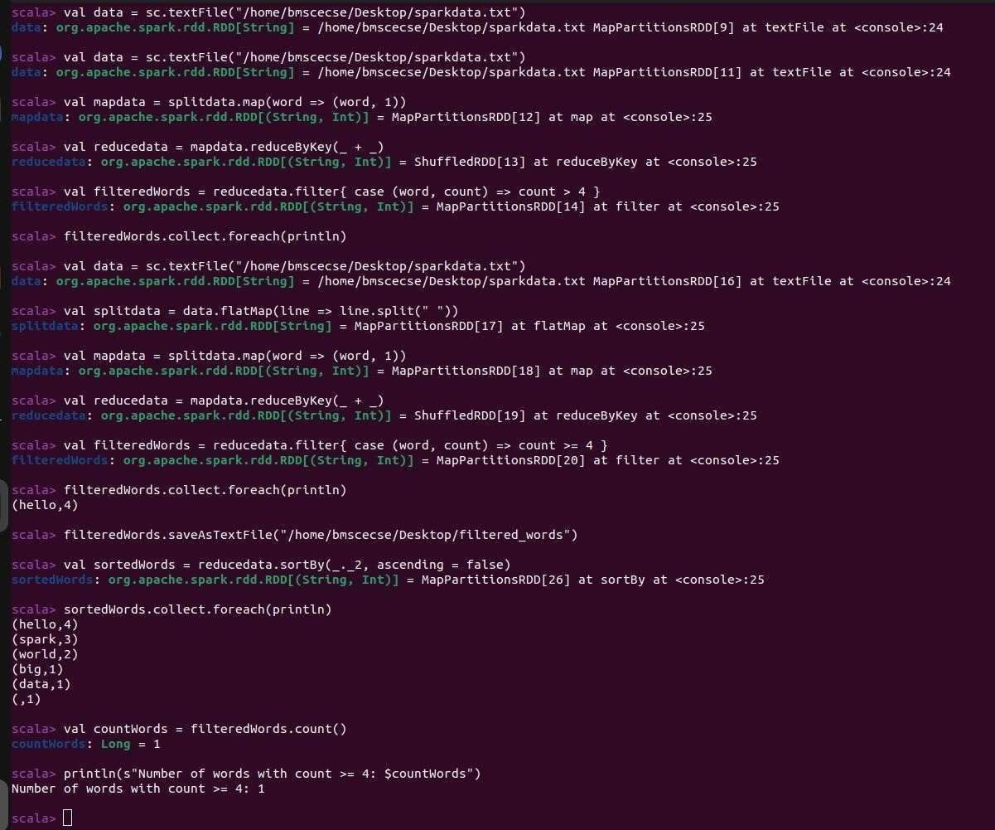

LAB 10

Write a simple streaming program in Spark to receive text data streams on a particular port, perform basic text cleaning (like white space removal, stop words removal, lemmatization, etc.), and print the cleaned text on the screen. (Open Ended Question).

import org.apache.spark.SparkConf import org.apache.spark.streaming.{Seconds, StreamingContext} import org.apache.spark.streaming.StreamingContext._

object SimpleStreamingCleaner {
def main(args: Array[String]): Unit = {
// Create Spark configuration and StreamingContext val conf = new SparkConf().setMaster("local[2]").setAppName("StreamingTextCleaner") val ssc = new StreamingContext(conf, Seconds(5))

// Connect to socket stream (e.g., using: `nc -lk 9999`) val lines = ssc.socketTextStream("localhost", 9999)

// Define stop words val stopWords = Set("a", "an", "the", "is", "in", "on", "and", "of", "to", "this", "that")

// Define basic lemmatization map (for demo only) val lemmaMap = Map("running" -> "run", "tests" -> "test", "files" -> "file", "words" -> "word")

// Clean the text stream val cleaned = lines.map(_.toLowerCase.trim) // lower case and trim
.flatMap(_.split("\\s+")) // split into words
.filter(word => !stopWords.contains(word)) // remove stop words
.map(word => lemmaMap.getOrElse(word, word)) // basic lemmatization

// Print the cleaned text cleaned.print()

// Start the stream ssc.start() ssc.awaitTermination()
}
}
OUTPUT

